SIMATS ENGINEERING
Harini G
192524011
ASSESSMENT TOOL 2 - Medium (LABORATORY PERFORMANCE)

COURSE CODE: CSA09 COURSE NAME: Programming in
Java

COURSE OUTCOME COVERED

CO4: Design and develop GUI-based user interfaces using Abstract Window Toolkit, Swing, and Applets by implementing event handling, layout managers, AWT controls, and menus. (BL3,BL5)

Assessment Tool Weightage: 10%

QUESTIONS: 5 Total Marks: 50

ANNEXURE A

LABORATORY PERFORMANCE

Code of Conduct:

I Harini G/192524011 (Name / Reg No) certify that this submission is my original work and that I have adhered to the guidelines specified for this assessment.
I understand that any violation of academic integrity rules will result in disciplinary action.

Signature of the student:
Harinigopi

ANNEXURE

LABORATORY PERFORMANCE

1. Student Registration Applet
Develop a Java Applet for a university student registration form. The applet should display labels and input controls for Student Name, Register Number, Department, Gender, and Email ID.The application should use appropriate AWT controls such as Label, TextField, Checkbox, CheckboxGroup, and Button. Use a suitable layout manager to organize the controls.When the student clicks the Submit button, the entered information should be displayed within the applet window.
The student must demonstrate:
- Applet initialization and architecture.
- AWT controls.
- Layout management.
- Button event handling.
- Appropriate event listener interface.
- Display of user-entered information.

2. Simple Calculator Applet
Develop an Applet-based calculator that accepts two numbers and provides buttons for Addition, Subtraction, Multiplication, and Division.
The application should use TextField, Label, and Button controls. Appropriate event listeners must be implemented so that clicking each button performs the corresponding operation.
The program must handle invalid numeric input and division by zero appropriately.
The student must demonstrate:
- Basic Applet structure.
- AWT controls.
- Event sources and event objects.
- ActionListener.
- Exception handling.
- Display methods.

3. Course Selection Applet
Develop a university course selection Applet where students can select:
- Department
- Semester
- Course
- Elective type
Use Choice, List, Checkbox, and Button controls wherever appropriate.
When the student clicks Register, display the selected courses and other information.
Use appropriate layout managers and event listeners.

4. Traffic Signal Control Applet
Develop an AWT Applet that simulates a traffic signal with three options:
- Red
- Yellow
- Green
Use appropriate controls to allow the user to select a signal. When the user selects a signal, display the corresponding message such as STOP, WAIT, or GO.
Use appropriate event sources, event classes, and listener interfaces.

RUBRICS FOR CALCULATION:

Criteria | Weightage | Level 4 – Exemplary | Level 3 – Proficient | Level 2 – Developing | Level 1 – Beginning
Problem Understanding & Program Design | 20% | Clearly understands the problem and develops an effective design | Good understanding and logical design | Basic understanding with some gaps | Poor understanding and unclear design
Java Implementation & Concept Application | 30% | Applies Java concepts correctly and effectively | Applies concepts with minor errors | Limited application of concepts | Incorrect or incomplete implementation
Program Execution & Output | 20% | Program executes correctly and produces accurate output | Executes with minor errors | Partially executes with some errors | Fails to execute correctly
Testing & Debugging | 15% | Thoroughly tests and resolves errors independently | Tests and resolves most errors | Performs limited testing and debugging | Unable to test or debug effectively
Documentation & Presentation | 15% | Complete, clear, and well-organized documentation | Good documentation with minor gaps | Basic documentation with some gaps | Incomplete or unclear documentation

QUESTION 1:
CODE:
import java.applet.Applet;
import java.awt.*;
import java.awt.event.*;

public class StudentRegistration extends Applet implements ActionListener
{
Label l1, l2, l3, l4, l5, result;
TextField t1, t2, t3, t4;
Choice dept;
Checkbox male, female;
CheckboxGroup gender;
Button submit;

public void init()
{
setLayout(new GridLayout(7, 2, 5, 5));

l1 = new Label("Student Name:");
t1 = new TextField();

l2 = new Label("Register Number:");
t2 = new TextField();

l3 = new Label("Department:");
dept = new Choice();
dept.add("CSE");
dept.add("ECE");
dept.add("IT");
dept.add("EEE");

l4 = new Label("Gender:");
gender = new CheckboxGroup();
male = new Checkbox("Male", gender, true);
female = new Checkbox("Female", gender, false);

l5 = new Label("Email ID:");
t3 = new TextField();

submit = new Button("Submit");
result = new Label("");

add(l1);
add(t1);

add(l2);
add(t2);

add(l3);
add(dept);

add(l4);
Panel p = new Panel();
p.add(male);
p.add(female);
add(p);

add(l5);
add(t3);

add(submit);
add(result);

submit.addActionListener(this);
}

public void actionPerformed(ActionEvent e)
{
String name = t1.getText();
String reg = t2.getText();
String d = dept.getSelectedItem();
String g = gender.getSelectedCheckbox().getLabel();
String email = t3.getText();

result.setText("Registered: " + name + " | " + reg + " | "
+ d + " | " + g + " | " + email);
}
}
Html CODE:
<html>
<body>
<applet code="StudentRegistration.class" width="600" height="300">
</applet>
</body>
</html>

OUTPUT:
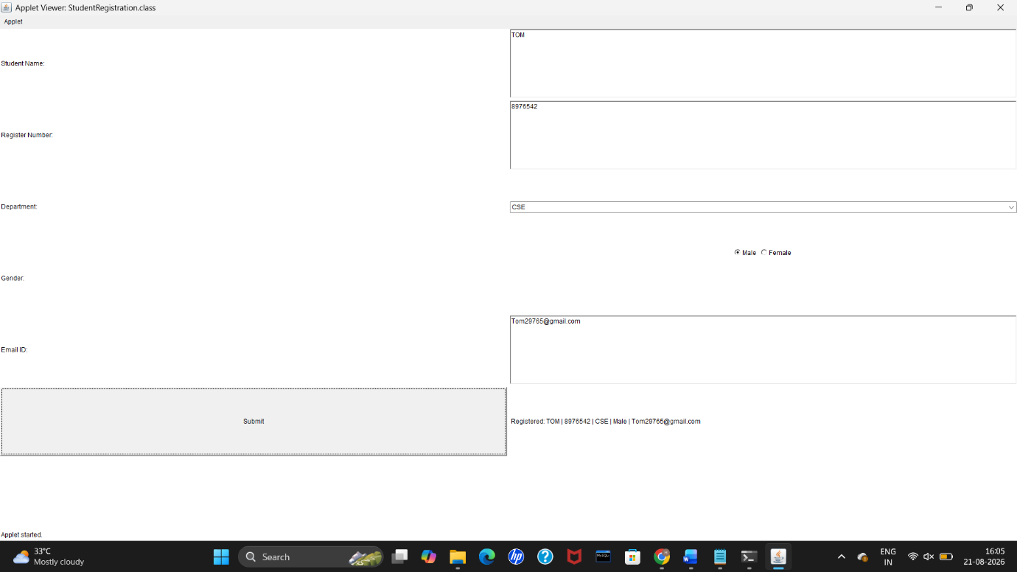

QUESTION 2:
CODE:
import java.applet.Applet;
import java.awt.*;
import java.awt.event.*;

public class CalculatorApplet extends Applet implements ActionListener
{
TextField t1, t2;
Button b1, b2, b3, b4;
Label result;

public void init()
{
setLayout(new FlowLayout());

add(new Label("First Number:"));
t1 = new TextField(10);
add(t1);

add(new Label("Second Number:"));
t2 = new TextField(10);
add(t2);

b1 = new Button("Addition");
b2 = new Button("Subtraction");
b3 = new Button("Multiplication");
b4 = new Button("Division");

add(b1);
add(b2);
add(b3);
add(b4);

result = new Label("Result:");
add(result);

b1.addActionListener(this);
b2.addActionListener(this);
b3.addActionListener(this);
b4.addActionListener(this);
}

public void actionPerformed(ActionEvent e)
{
try
{
double a = Double.parseDouble(t1.getText());
double b = Double.parseDouble(t2.getText());
double ans;

if(e.getSource() == b1)
{
ans = a + b;
result.setText("Result: " + ans);
}
else if(e.getSource() == b2)
{
ans = a - b;
result.setText("Result: " + ans);
}
else if(e.getSource() == b3)
{
ans = a * b;
result.setText("Result: " + ans);
}
else
{
if(b == 0)
{
result.setText("Cannot divide by zero");
}
else
{
ans = a / b;
result.setText("Result: " + ans);
}
}
}
catch(Exception ex)
{
result.setText("Invalid input");
}
}
}
Html CODE:
<html>
<body>
<applet code="CalculatorApplet.class" width="500" height="300">
</applet>
</body>
</html>
OUTPUT:

QUESTION 3:
CODE:
import java.applet.Applet;
import java.awt.*;
import java.awt.event.*;

public class CourseSelection extends Applet implements ActionListener
{
Choice department;
Choice semester;
List course;
Checkbox elective;
Button register;
Label result;

public void init()
{
setLayout(new FlowLayout());

add(new Label("Department:"));

department = new Choice();
department.add("CSE");
department.add("ECE");
department.add("IT");
department.add("EEE");
add(department);

add(new Label("Semester:"));

semester = new Choice();
semester.add("Semester 1");
semester.add("Semester 2");
semester.add("Semester 3");
semester.add("Semester 4");
add(semester);

add(new Label("Course:"));

course = new List(4, false);
course.add("Java");
course.add("Python");
course.add("Computer Networks");
course.add("DBMS");
course.add("Operating Systems");
add(course);

elective = new Checkbox("Elective Course");
add(elective);

register = new Button("Register");
add(register);

result = new Label("Select details and click Register");
add(result);

register.addActionListener(this);
}

public void actionPerformed(ActionEvent e)
{
String d = department.getSelectedItem();
String s = semester.getSelectedItem();
String c = course.getSelectedItem();

if(c == null)
{
result.setText("Please select a course");
}
else if(elective.getState())
{
result.setText(d + " | " + s + " | " + c + " | Elective");
}
else
{
result.setText(d + " | " + s + " | " + c + " | Regular");
}
}
}
Html CODE:
<html>
<body>

<applet code="CourseSelection.class" width="700" height="400">
</applet>

</body>
</html>
OUTPUT:
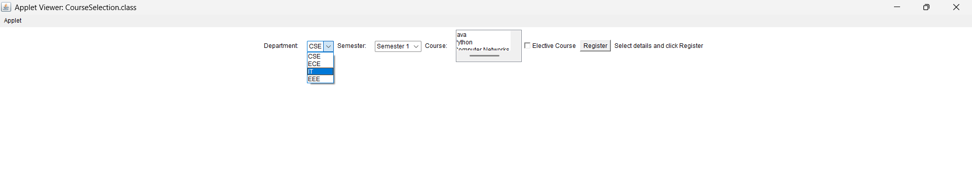

QUESTION 4:
CODE:
import java.applet.Applet;
import java.awt.*;
import java.awt.event.*;

public class TrafficSignal extends Applet implements ItemListener
{
Checkbox red, yellow, green;
CheckboxGroup signal;
Label message;

public void init()
{
setLayout(new FlowLayout());

signal = new CheckboxGroup();

red = new Checkbox("Red", signal, false);
yellow = new Checkbox("Yellow", signal, false);
green = new Checkbox("Green", signal, false);

add(red);
add(yellow);
add(green);

message = new Label("Select a signal");
add(message);

red.addItemListener(this);
yellow.addItemListener(this);
green.addItemListener(this);
}

public void itemStateChanged(ItemEvent e)
{
if(red.getState())
{
message.setText("STOP");
}
else if(yellow.getState())
{
message.setText("WAIT");
}
else if(green.getState())
{
message.setText("GO");
}
}
}
Html code:
<html>
<body>

<applet code="TrafficSignal.class" width="500" height="250">
</applet>

</body>
</html>
OUTPUT:



